Standardization Sector
ITU-T Technical Report
(11/2023)
TR.Reqts-SAN
Requirements of semantic-aware networking for future networks
ITUPublications | International Telecommunication Union

Technical Report ITU-T TR.Reqts-SAN
Requirements of semantic-aware networking for future networks

Summary
Semantic-aware network (SAN) adopts machine and human-shared semantic terms and syntax to represent, annotate, analyse, and interpret network and user generated data, and is a promising candidate to support automatic data analysing, processing, and learning for future networks including IMT-2020. This Technical Report identifies potential requirements of SAN for future networks.

Keywords
Future networks, IMT-2020, machine learning, QoS assurance requirements, semantic-aware networking, SAN.

Note
This is an informative ITU-T publication. Mandatory provisions, such as those found in ITU-T Recommendations, are outside the scope of this publication. This publication should only be referenced bibliographically in ITU-T Recommendations.

© ITU 2023
All rights reserved. No part of this publication may be reproduced, by any means whatsoever, without the prior written permission of ITU.

Table of Contents
Page
1 Scope 1
2 References 1
3 Terms and definitions 1
3.1 Terms defined elsewhere 1
3.2 Terms defined in this Technical Report 2
4 Abbreviations and acronyms 2
5 Conventions 2
6 Overview of SAN 2
7 General requirements of SAN 4
7.1 Domain-specific semantic ontology 4
7.2 Semantic domain relevance indexing 4
7.3 Semantic annotation 4
7.4 Semantic interpretation 4
7.5 Semantic translation 5
7.6 Semantic cognition 5
7.7 Semantic rationality discovery 5
7.8 Self-description and auto-correction 5
8 Requirements from the service point of view 6
8.1 Diverse service support 6
8.2 Diverse QoS support 6
8.3 Diverse QoE support 6
8.4 Interoperating with semantic irrelevant services 6
8.5 Cross-domain semantic model adaptation 6
8.6 Intra-domain semantic model adaptation 7
9 Requirements from the network operation point of view 7
9.1 Distributed semantic resource provisioning and discovery 7
9.2 Semantic capability exposure 7
9.3 Intra-network operation 7
9.4 Inter-network operation 8
10 Requirements from the data processing point of view 8
10.1 Semantic autocorrection 8
10.2 Semantic identification and representation 8
10.3 Semantic knowledge tracking and updating 8
10.4 Security and privacy protection 9
11 Use Cases 9
11.1 SAN-enabled autonomous driving 9
11.2 SAN-enabled environmental monitoring 9
Page
Bibliography 11

Technical Report ITU-T TR.Reqts-SAN
Requirements of semantic-aware networking for future networks

1 Scope
This Technical Report identifies potential requirements of semantic-aware networking (SAN) for future networks including IMT-2020.
The scope of this Technical Report includes:
– overview of SAN;
– general requirements of SAN;
– SAN requirements from the service point of view;
– SAN requirements from the network operation point of view;
– SAN requirements from the data processing point of view;
– use cases.

2 References
[ITU-T Y.3172] Recommendation ITU-T Y.3172 (2019), Architectural framework for machine learning in future networks including IMT-2020.
[ITU-T Y.3174] Recommendation ITU-T Y.3174 (2020), Framework for data handling to enable machine learning in future networks including IMT-2020.
[ITU-T Y.4111] Recommendation Y.4111/Y.2076 (2016), Semantics based requirements and framework of the Internet of things.

3 Terms and definitions

3.1 Terms defined elsewhere
This Technical Report uses the following terms defined elsewhere:
3.1.1 application domain [b-ITU-T Y.4100]: An area of knowledge or activity applied for one specific economic, commercial, social or administrative scope.
NOTE – Transport application domain, health application domain and government application domain are examples of application domains.
3.1.2 domain [b-ITU-T X.1252]: An environment in which an entity can use a set of attributes for identification and other purposes.
3.1.3 machine learning (ML) [ITU-T Y.3172]: Processes that enable computational systems to understand data and gain knowledge from it without necessarily being explicitly programmed.
NOTE 1 – This definition is adapted from [b-ETSI GR ENI 004].
NOTE 2 – Supervised machine learning and unsupervised machine learning are two examples of machine learning types.
3.1.4 machine learning model [ITU-T Y.3172]: Model created by applying machine learning techniques to data to learn from.
NOTE 1 – A machine learning model is used to generate predictions (e.g., regression, classification, clustering) on new (untrained) data.
NOTE 2 – A machine learning model may be encapsulated in a deployable fashion in the form of a software (e.g., virtual machine, container) or hardware component (e.g., IoT device).
NOTE 3 – Machine learning techniques include learning algorithms (e.g., learning the function that maps input data attributes to output data).
3.1.5 ontology [b-ITU-T X.1570]: An explicit specification of a conceptualization.
3.1.6 semantics [b-ITU-T Z.341]: The rules and conventions governing the interpretation and assignment of meaning to constructions in a language.

3.2 Terms defined in this Technical Report
This Technical Report defines the following terms:
3.2.1 semantic-aware networking (SAN): Networking that exploits semantics to assist the learning, communication and interpretation of the intended meaning.
3.2.2 semantic domain: An environment that involves one or multiple ontologies associated to a certain field of knowledge.

4 Abbreviations and acronyms
This Technical Report uses the following abbreviations and acronyms:
AR Augmented reality
IoT Internet of Things
ML Machine Learning
QoE Quality of Experience
SAN Semantic-aware Networking
UE User Equipment
VR Virtual reality
XR Extended reality

5 Conventions
In this Technical Report, potential requirements which are derived from a given use case, are classified as follows:
The keywords "it is of critical value" indicate a possible requirement which would be necessary to be fulfilled (e.g., by an implementation) and enabled to provide the benefits of the use case.
The keywords "it is expected" indicate a possible requirement which would be important but not absolutely necessary to be fulfilled (e.g., by an implementation). Thus, this possible requirement would not need to be enabled to provide complete benefits of the use case.
The keywords "it is of added value" indicate a possible requirement which would be optional to be fulfilled (e.g., by an implementation), without implying any sense of importance regarding its fulfilment. Thus, this possible requirement would not need to be enabled to provide complete benefits of the use case.

6 Overview of SAN
Recent developments of communication and networking technologies have witnessed a growing interest on services such as Tactile Internet and virtual reality (VR)/augmented reality (AR)/extended reality (XR), most of which are data-hungry and can constantly generate a huge volume of data at a tremendous speed. There is a pressing need to develop novel cost-effective solutions to support automatic data analysing, processing, and learning for future networks including IMT-2020 [b-SAN] [b-ITW].
Semantic-aware networking (SAN) is an important solution to meet the above need and support diverse smart applications and services based on the network user/device generated data. The key idea is to adopt machine and human-shared semantic terms and syntax to represent, annotate, analyse, and interpret data and services in the network. SAN seamlessly converges the networking, artificial intelligence and human user-oriented services, and has the potential to enable new features and capabilities in the future networks. In particular, SAN has the potential to enable the following novel features and capabilities:
1) Cost-effective auto-data processing/pre-processing: SAN allows the data generated by UEs and services to be automatically discovered, classified, and/or associated with common semantic annotations for easy analysing and processing.
2) Enhanced interoperability: based on SAN, the data and services associated with different sources, applications, networks, and systems can be automatically interpreted and converted into the same semantic domain which enables improved data and service interoperation between different application, network and system domains.
3) Self-learning and inferencing: in SAN, both the network and/or user UE can utilize semantic-annotated data arrived at the network and/or received by the user equipment to automatically train suitable ML models. The network and/or UE can also infer possible (causal or logical) relations between different semantic annotations as well as syntax in different network systems and protocols.
4) Self-evolving and adapting: SAN allows network and UE to identify unrecognizable and/or unknown semantics and automatically infer the possible relations between the unknown data combination, patterns, and behaviour with existing semantics.
5) Network abnormal/disaster discovery and recovery: in SAN, the network is able to identify unusual data traffic patterns, relations, syntax, and rules and can therefore support automatic discover and alarm of network abnormality and disaster. SAN also allows network operators to automatically correct the abnormal data traffic or routing paths based on the pre-identified or pre-trained rules.
SAN can be adopted by different network functions to enable different skillsets and capabilities [b-SAN-AI for Good]. For example, in the core network, SAN can be implemented to support advanced network automation, such as automatic fault detection and recovery within the same networking system or across different network platforms. In the access network, SAN can enable more advanced network access control function such as automatic access network selection and configuration. SAN can also help to support more user-friendly interface for various user equipment and services. In the data network, SAN can support automatic data processing and analysis.
SAN can improve the performance of both traditional and emerging applications and use scenarios [b-SI]. For example, in the case of smart factory, SAN can help to design an enhanced human-machine interface which can help machines at various stages of manufacturing process to obtain a better understanding of human operator's instructions. In network fault management, SAN can help human operators to obtain a better understanding of the network issues and provide necessary solutions. Various components in the networking system can also observe and learn from the operation of the human operator to support automatic detection and recovery of the same or similar fault in the future. In the network slicing case, SAN can help the resource orchestrator/controller to orchestrate the network resources as well as the placement of functionality according to the various needs of service users.
This Technical Report addresses potential requirements of semantic-aware networking in order to promote awareness for relevant networking services and applications to use and deploy semantic-aware knowledge and syntax in supporting highly efficient human-oriented networking services. It is also expected to promote relevant standardization in this area, including smooth, feasible and standardized solutions for relevant networking services and applications.

7 General requirements of SAN

7.1 Domain-specific semantic ontology
Domain-specific semantic ontology is a set of concepts, relationships, and rules associated with a specific domain.
It is of critical value that SAN supports domain-specific semantic ontology for semantic discovery, annotation, self-description, interpretation, and interoperation in a specific domain.
NOTE – Semantic ontology may include a set of domain-specific semantic ontologies that can be associated with different use cases. It provides a standardized and shared understanding of meaning within each domain as well as between different domains. It allows for more accurate and efficient data processing and retrieval by annotating and describing data that is specific to each domain.

7.2 Semantic domain relevance indexing
Semantic domain relevance indexing enables evaluating the relevance of data to a particular semantic domain. It is helpful for interpreting and annotating data based on the most relevant domain knowledge.
It is of critical value that SAN supports semantic domain relevance indexing for evaluating the relevance of data in each specific domain.
NOTE – The semantic domain relevance indexing enables more efficient and accurate data annotation and interpretation within a specific domain. It may also enable discovery of new relationships and insights when interpreting data across multiple different domains.

7.3 Semantic annotation
Semantic annotation, as a non-intrusive technique, is generally used for semantic description of data in order to describe characteristics of resources and to indicate relationships between resources in a consistent and maintainable way.
It is of critical value that semantic annotation is applied in SAN to improve data interoperability, facilitate knowledge sharing and decision making based on the semantics of the data for SAN.
NOTE 1 – In SAN, the data patterns and behaviours as well as relevant resources can be described based on the semantic annotations. These annotations are important to build a common understanding of the exchanged data as well as their "intentions" [b-ITU-T Y.2344] among different network components, functions, and operators, such as networks, machines, human operators and services. They are also useful for enabling automatic data annotation, feature discovery, automatic operations, self-learning, interoperability among different networking components, and smooth interaction between human and machines.
NOTE 2 – Semantic annotations can be introduced and/or pre-defined for different services and applications to describe different data traffic patterns, characteristics, and behaviours.

7.4 Semantic interpretation
Semantic interpretation is the process of understanding the meaning of data based on the annotated data as well as other relevant concepts, relationships, and domain ontologies.
It is of critical value that SAN supports semantic interpretations based on semantic domain-specific ontologies, domain relevance indexing, rules, and relations with other concepts and domains.
NOTE – The semantic annotations and descriptions can be interpreted based on the possible meaning, rules, and relations based on one or multiple domain-specific semantic ontologies and rules. These meanings and rules can be either explicit, such as coexisting and scheduling patterns that can be directly observed from the data, as well as implicit, such as hidden rules that need to be inferred based on rationality, common knowledge, and facts [b-ICC].

7.5 Semantic translation
Semantic translation is the process of mapping annotations and meanings of data from one domain to another.
It is of critical value that SAN supports semantic translation of meaning of data from one domain to another.
NOTE 1 – The data exchanged and arrived at the user equipment (UE) and network can be annotated and interpreted based on one selected domain specific semantic ontology and then be translated into another set of interpretations in another domain.
NOTE 2 – Semantic translation enables UEs to understand each other.
NOTE 3 – Semantic translation is a key technology in the field of semantic computing, enabling seamless integration between different systems and applications.

7.6 Semantic cognition
Semantic cognition is a set of technologies that can help identifying whether the data contains any useful meaning as well as its importance in the intended service or tasks.
It is of critical value that SAN supports semantic cognition to identify significance or importance of the data in interpretation and translation of semantics in different domains.
NOTE 1 – Semantic cognition can be implemented by existing machine learning algorithms to automatically categorize data according to their significance.
NOTE 2 – Semantic cognition can be assisted by sensing and discovering relevant side information such as environment, application scenario, time, destination and context of communication.

7.7 Semantic rationality discovery
The SAN is expected to support the discovery of world or language-based common-sense knowledge, facts, and data rationality.
It is of critical value that SAN supports semantic rationality to make decisions based on the meaning of the data, not just its structure.
NOTE – The semantic ontology serves as the foundation for semantic rationality, providing the network with a shared understanding of the data's meaning. This allows SAN to accurately interpret and analyse the data, leading to improved decision-making and enhanced outcomes. Incorporating semantic rationality into SAN can drive innovation, reduce costs, and increase customer satisfaction.

7.8 Self-description and auto-correction
Self-description and auto-correction in SAN refer to the ability of automatic annotation and correction of semantic information that does not make sense and contradicts facts according to the discovered semantic rationality.
It is of critical value that SAN supports self-description and correction to provide self-description and auto-correction services to improve the reliability, scalability, and adaptability of the network.
NOTE – Self-description and auto-correction capabilities are closely related to data annotation as well as discovered semantic ontology and rationality. These capabilities reduce the implementation complexity and cost of SAN.

8 Requirements from the service point of view

8.1 Diverse service support
Diverse service support refers to the capability of the SAN to efficiently provide and manage a wide range of services. Clause 11 provides some use case examples.
It is of critical value that SAN supports highly diversified services and applications.
NOTE – Different services may be associated with different sets of semantic annotation, ontologies, and rationality in different domains. Each service may also involve semantics from multiple domains.

8.2 Diverse QoS support
Diverse QoS support for SAN refers to providing QoS support for a variety of different services, different traffic loads, and different end user communities.
It is of critical value that SAN assures requirements for different services such as machine type communication (MTC), enhanced mobile broadband (eMBB), and ultra-reliable low latency communications (URLLC).
NOTE 1 – QoS key performance indicators (KPIs) include data rate, user density and user mobility. Other QoS KPIs, such as those specified in [b-ITU-T E.811], may also be included.
NOTE 2 – Each service may have different priority in different QoS requirements. This may help avoid network congestion and also improve the reliability of more critical data and applications.

8.3 Diverse QoE support
Diverse QoE support in SAN refers to the support of a set of user's subjective performance metrics including user emotion, user habit and user expectation.
It is of critical value that SAN provides diverse QoE support for different users.
NOTE 1 – For some services, QoE and QoS need to be jointly considered and optimized.
NOTE 2 – The subjective annotation and interpretation of data can be helpful for evaluating the QoE of various services.
NOTE 3 – Diverse QoE may be enabled by accurate reconstruction of past events, timely detection of current events, and high-confidence prediction of future events.

8.4 Interoperating with semantic irrelevant services
Interoperating with semantic irrelevant services addresses interoperability at the semantic level [b-SI], based on the meaning of exchanged data between semantic relevant services and semantic irrelevant services (i.e., services which do not support any semantic capabilities such as semantic translation, auto-correction, etc.).
It is of critical value that SAN supports interoperation at the semantic level so that the data transferred across different SAN components can be easily understood by each SAN technical component.
NOTE 1 – The meaning of exchanged data can be described via semantic annotation.
NOTE 2 – Interoperating with semantic irrelevant services ensures compatibility of SAN with the existing semantic-irrelevant services.

8.5 Cross-domain semantic model adaptation
Cross-domain semantic model adaptation refers to the ability of SAN to adapt and apply semantic models across different domains, facilitating meaningful data interpretation, communication, and service provision in multi-domain environments [b-JSAC].
It is of critical value that SAN identifies the specific domains of the relevant semantics and supports cross-domain semantic model adaptation and application among different domains.
NOTE 1 – Semantic model is a representation structure for data that can organize information as semantic elements in the structure and ensure consistent meaning of the semantic elements and their relationships.
NOTE 2 – Cross-domain semantic adaptation can help to improve the efficiency and effectiveness of semantic interpretation and translation by leveraging on existing semantic models. It involves developing methodological and technical model adaptation methods that can be used across multiple domains.

8.6 Intra-domain semantic model adaptation
Intra-domain semantic model adaptation refers to the ability of SAN to adapt and reuse semantic models across different sub-domains of the same domain.
It is of critical value that SAN supports knowledge sharing in different sub-domains of the same domain.
NOTE – As an example, the communication between different services sharing the same knowledge of different sub-domains within a given domain can utilize compatible terms of the shared knowledge to further improve its efficiency and avoid misinterpretation of the message.

9 Requirements from the network operation point of view

9.1 Distributed semantic resource provisioning and discovery
Distributed semantic resource provisioning and discovery refer to the process of discovering and provisioning semantic resources, including domain-specific semantic ontologies and semantic annotated data, in a distributed manner.
It is of critical value that SAN supports distributed provisioning and discovery of different semantic resources.
NOTE – This allows for more efficient resource utilization and management, as well as easier sharing and integration of resources within and across networks.

9.2 Semantic capability exposure
Semantic capability exposure refers to the ability of SAN to expose its semantic capabilities such as semantic translation, auto-correction, etc. to external entities, such as other networks or application domains [b-ITU-T Y.4100].
It is of critical value that SAN supports semantic capability exposure in order to expose the semantic capabilities that are available to other entities such as networks, services, users, etc.
NOTE 1 – For example, semantic capability exposure can make more informed decision-making in resource allocation and usage to improve network performance.
NOTE 2 – Implementation of adequate security measures can help protect sensitive data during semantic capability exposure, see clause 10.4.

9.3 Intra-network operation
Intra-network operation of SAN refers to the management of communication, data transfer, and resource allocation within a single network with the same semantic rules and models.
It is of critical value that SAN supports intra-network operation.
NOTE 1 – Intra-network operation may enable optimal resource management, enhanced data processing, improved quality of service, robust security measures, and overall operational efficiency within a single network.
NOTE 2 – In the context of SAN, intra-network operation involves the efficient and effective management of semantic related capabilities within the network, including discovery, annotation, self-description, interpretation, and interoperation capabilities.

9.4 Inter-network operation
Inter-network operation of SAN refers to the resource management and control across multiple networks.
It is of critical value that SAN supports inter-network operation, including communication, resource utilization and semantic annotation across different networks.
NOTE 1 – Inter-network operation may enable seamless communication, efficient resource utilization and semantic annotation consistency across different networks, maintaining security and integrity of data, and facilitating collaboration and integration of data from multiple networks.
NOTE 2 – A standardized semantic annotation format may be helpful to ensure smooth data exchange and process across different networks.
NOTE 3 – Robust and reliable data transfer protocols may ensure data integrity and minimize data loss during transmission.
NOTE 4 – Implementation of adequate security measures can help protect sensitive data during inter-network communication, see clause 10.4.

10 Requirements from the data processing point of view

10.1 Semantic autocorrection
Semantic autocorrection is the ability of automatically detecting and correcting errors or inconsistencies in semantic annotations.
It is of critical value that SAN supports semantic autocorrection based on common-sense knowledge, reasoning, and inference rules.
NOTE – Semantic autocorrection can be achieved using various existing techniques such as semantic rules, ontologies, and some AI/ML algorithms.

10.2 Semantic identification and representation
Semantic identification and representation refer to the process of recognizing and structuring data based on its inherent meaning and context.
It is of critical value that SAN supports semantic identification and representation to facilitate effective understanding, interpretation, and utilization of data, thereby enhancing communication, data processing, and service provision based on the inherent meaning and context of the data.
It is expected that semantic identification maintains consistency in representation to facilitate effective data communication and processing within and across networks.

10.3 Semantic knowledge tracking and updating
Semantic knowledge tracking and updating refers to the ability of SAN to discover new semantic concepts, such as knowledge related terms, as well as discover variations of the meaning of some semantic annotations [b-ICCW].
It is of critical value that SAN supports semantic knowledge tracking and updating.
NOTE 1 – Semantic knowledge tracking and updating may involve adding, modifying or removing concepts, relationships, rules, and axioms in the semantic model.
NOTE 2 – New concepts may be introduced due to the human society's social interaction and knowledge evolution.
NOTE 3 – SAN may keep track of some semantic concepts, which might be helpful for SAN to identify new semantic concepts and introduce annotations associated with these new semantic concepts.
NOTE 4 – SAN may support modelling and tracking of temporal variations of semantic knowledge, e.g., aggregating new knowledge entities and relations, and discarding obsolete information,

10.4 Security and privacy protection
Security and privacy protection of SAN refer to the techniques and measures introduced to protect the semantic capabilities from unauthorized access, misuse, and malicious attacks.
It is of critical value that SAN implements security and privacy protection measures to protect the semantic capabilities from unauthorized access, misuse, and malicious attacks.
NOTE – Security and privacy protection of SAN may be helpful to ensure the integrity and confidentiality of semantic data, protect system capabilities from unauthorized access, and maintain trustworthiness of intra-network and inter-network operations.

11 Use Cases
SAN can support a wide range of services. The following illustrates two example use cases.

11.1 SAN-enabled autonomous driving
In this application scenario, different types of sensors, such as cameras and LiDAR sensors, have been installed to help make driving decisions of an autonomous driving vehicle. SAN can be applied in this scenario to further enhance the decision making of autonomous driving vehicles. Data samples collected by different sensors generally have different formats and implications. These data samples can be semantically annotated and jointly interpreted to further enhance the decision making of the autonomous driving vehicle.
More specifically, in this application scenario example, data samples collected by a LiDAR sensor have detected an obstacle at a certain distance in front of the vehicle. Data samples collected by cameras are used to semantically annotate the LiDAR data samples. In particular, camera data samples are processed by some AI models to identify the semantic labels of LiDAR data samples, e.g., the types of the obstacle. If the detected object is a moving pedestrian that is walking across the street, the vehicle applies semantic interpretation to infer and predict the path and speed of the pedestrian, and to wait until the pedestrian has finished the street crossing or moved into a safe location. In case that the detected object is a static obstacle, e.g., a falling rock, the vehicle needs then to plan a path to bypass the static obstacle.
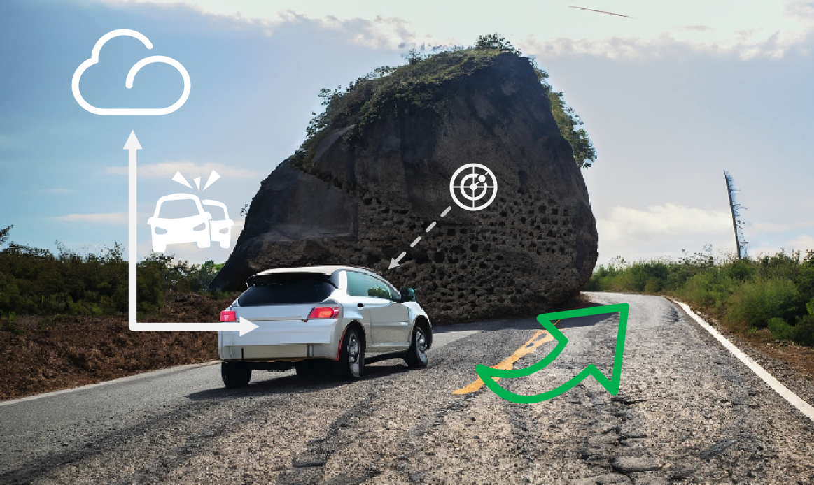
Figure 11-1 – SAN-enabled autonomous driving

11.2 SAN-enabled environmental monitoring
In this application scenario, a large number of different types of low-cost sensors is deployed across a wide geographical area to monitor various environmental variables such as temperature, humidity, air-quality of the area. These data samples can be semantically interpreted and described to quickly and accurately discover and predict potential natural disasters throughout the monitored area.
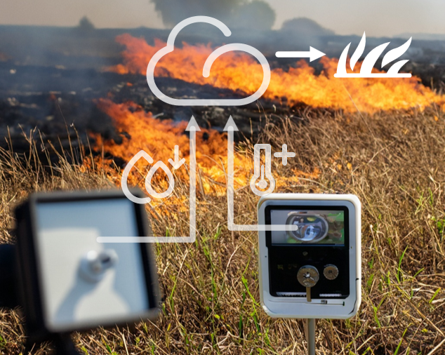
Figure 11-2 – SAN-enabled environmental monitoring
In the application scenario example of monitoring the environmental condition of a remote forest area, if a temperature sensor records an unusually high temperature data, this data can be semantically interpreted with other types of neighbouring sensors to identify whether there is a malfunction of a sensor device or a high-risk ignition point of a wildfire. In particular, data collected by a neighbouring camera sensor is applied to semantically annotate the temperature sensor data and decide whether or not the high temperature data is caused by a wildfire or device malfunction. Semantic autocorrection is applied to ignore the high temperature data if the camera data detects that the high temperature data is caused by device malfunction.

Bibliography

[b-ITU-T E.811] Recommendation ITU-T E.811 (2017), Quality measurement in major events.
[b-ITU-T X.1252] Recommendation ITU-T X.1252 (2021), Baseline identity management terms and definitions.
[b-ITU-T X.1570] Recommendation ITU-T X.1570 (2011), Discovery mechanisms in the exchange of cybersecurity information.
[b-ITU-T Y.2344] Recommendation ITU-T Y.2344 (2022), Scenarios and requirements of Intent-Based Network for network evolution.
[b-ITU-T Y.4100] Recommendation ITU-T Y.4100/Y.2066 (2014), Common requirements of the Internet of things.
[b-ITU-T Z.341] Recommendation ITU-T Z.341 (1988), Man-machine language – Glossary of terms.
[b-ICC] Zhimin Lu, Yong Xiao, Zijian Sun, Yingyu Li, Guangming Shi, Xianfu Chen, Mehdi Bennis, and H. Vincent Poor (2023), Adversarial Learning for Implicit Semantic-Aware Communications, IEEE International Conference on Communications (ICC), Rome, Italy, May.
[b-ICCW] Jingming Liang, Yong Xiao, Yingyu Li, Guangming Shi, and Mehdi Bennis (2022), Life-Long Learning for Reasoning-Based Semantic Communication, IEEE International Conference on Communications (ICC) Workshop, Seoul, South Korea, May.
[b-ITW] Yong Xiao, Xu Zhang, Yingyu Li, Guangming Shi, and Tamer Başar (2022), Rate-distortion Theory for Strategic Semantic Communication, IEEE Information Theory Workshop (ITW), Mumbai, India, November.
[b-JSAC] Yong Xiao, Zijian Sun, Guangming Shi, Dusit Niyato (2023), Imitation Learning-based Implicit Semantic-aware Communication Networks: Multi-layer Representation and Collaborative Reasoning, IEEE Journal on Selected Areas in Communications (JSAC), vol. 41, no. 3, pp. 639-658, March.
[b-SAN] Guangming Shi, Yong Xiao, Yingyu Li, and Xuemei Xie (2021), From Semantic Communication to Semantic-aware Networking: Model, Architecture, and Open Problems, IEEE Communications Magazine, vol. 59, no. 8, August.
[b-SAN-AI for Good] ITU-T AI for Good 2022 webinar: Semantic-aware Networking: Model, Architecture, and Open Problems, April.
[b-SI] European Research Cluster on the Internet of Things, IoT Semantic Interoperability: Research Challenges, Best Practices, Solutions and Next Steps, IERC AC4 Manifesto "Present and Future".

_____________________

